FORNAX™ ePlanCheck Rule
Rule Information
Rule ID | WTR 6.4.7
Rule Name | Provision of Stopvalves
Chapter | 2 Distribution
Section | 2.4 Services
Handbook | Code of Practice for Water Services  Incorporating Amendment No. 1 and No. 2 – CP 48 : 2005

Rule Description
2.4 Services

2.4.7 A stopvalve should be provided in the service pipe in an accessible position inside the property as near as praticable to the point of entry of the pipe next to the meter so that the supply may be readily shut off in case of trouble and for repairs. Where a building is divided into flats or other separately occupied parts which are supplied from a common service pipe, there should be a stopvalve to control the supply to each flat, fixed after the meter so as to be under the control of each occupiers. Another stopvalve should be fixed before the meter to facilitate installation and removal of the meter from Authority. The service pipe should be so arranged it does not pass through any such part of the building on its way to give a supply elsewhere. Where water is supplied to flats or other separately occupied parts of a building through a common distributing pipe from a storage tank, the distributing pipe should be arranged and stopvalves fixed before and after the sub meter positions, as described.

Rule Interpretation
- This rule checks for the provision of stopvalve in the service pipe next to meter; this is to shut off the specific section for repair in case of water leak or line trouble. (Figure 01)
- For a building divided into flats, this also checks for the provision of stopvalve next to meter provided in each flats to control the water supply and to be under control of the occupiers. There should also be a stopvalve before the water meter in case of installation and/or removal of meter by the Authority. (Figure 02)
- Valve is a device for controlling the passage of fluid or air through a pipe, etc., especially an automatic device allowing movement in one direction only.

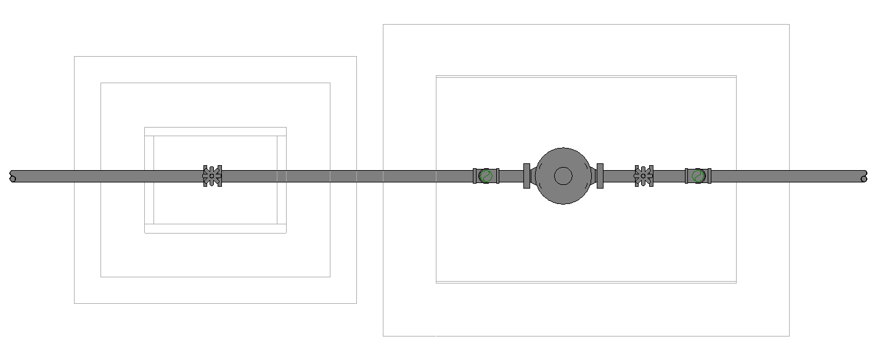
MAIN WATER METER

FROM
PUB MAIN
TO BUILDING

STOP VALVE

PROVISION OF STOPVALVE
PLAN VIEW

INDIVIDUAL WATER
SUB-METER
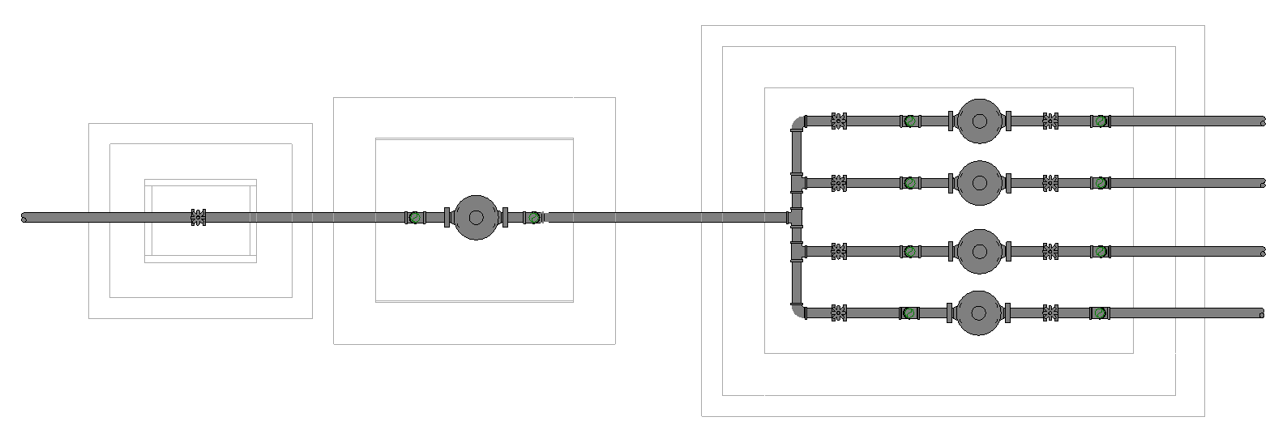
MAIN WATER METER

FLAT A
FROM
PUB MAIN
FLAT B

FLAT C
FLAT D

STOP VALVES

PROVISION OF STOPVALVES
PLAN VIEW

Rule Scenario

Scenario 01 – Compliant
Requirement | Provision of stop valve next to water meter going to a building.
Description | Provision of stop valve next to water meter going to a building.
MAIN WATER METER

FROM
PUB MAIN
TO BUILDING

STOP VALVE

PLAN
FIGURE SCENARIO

Scenario 02 – Compliant
Requirement | Provision of stop valves before and after the meter of each flats of the building.
Description | Provision of stop valves before and after the meter of each flats of the building.
INDIVIDUAL WATER
SUB-METER
MAIN WATER METER

FLAT A
FROM
PUB MAIN
FLAT B

FLAT C
FLAT D

STOP VALVES

PLAN
FIGURE SCENARIO

Scenario 01 – Non-Compliant 1
Requirement | Provision of stopvalve next to water meter going to a building.
Description | No stop valve next to meter going to a building.
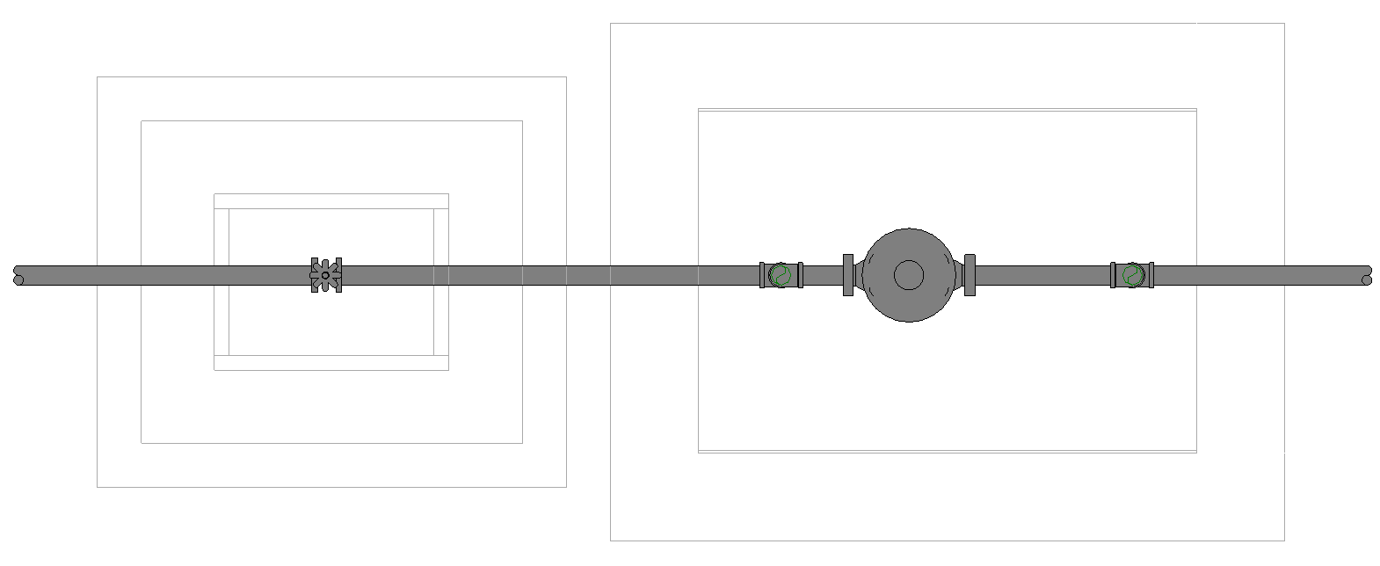
MAIN WATER METER

FROM
PUB MAIN
TO BUILDING

PLAN
FIGURE SCENARIO

Scenario 02 – Non-Compliant 1
Requirement | Provision of stopvalves before and after the meter of each flats of the building.
Description | No stop valve before and after the meter of each flats of the building.
INDIVIDUAL WATER
SUB-METER
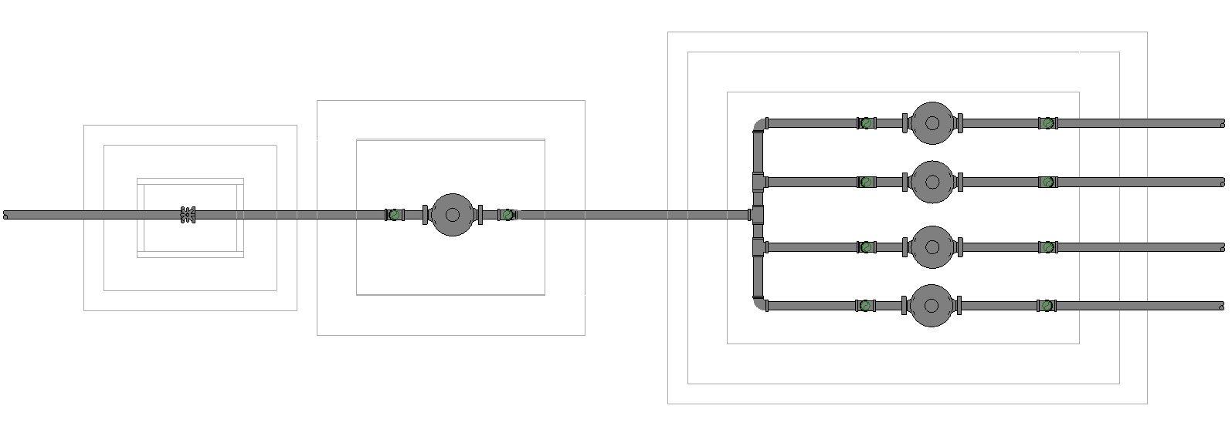
MAIN WATER METER

FLAT A
FROM
PUB MAIN
FLAT B

FLAT C
FLAT D

PLAN
FIGURE SCENARIO

Scenario 02 – Non-Compliant 2
Requirement | Provision of stopvalves before and after the meter of each flats of the building.
Description | No stopvalve before the meter of each flat of the building.
INDIVIDUAL WATER
SUB-METER
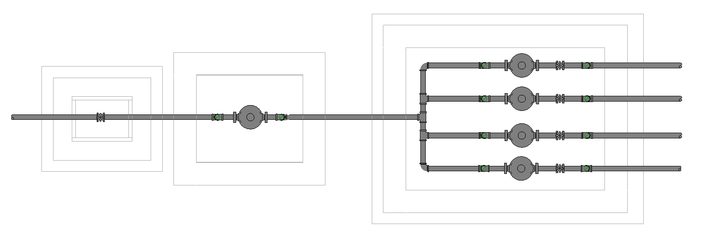
MAIN WATER METER

FLAT A
FROM
PUB MAIN
FLAT B

FLAT C
FLAT D

STOP VALVES
PLAN
FIGURE SCENARIO

Scenario 02 – Non-Compliant 3
Requirement | Provision of stopvalves before and after the meter of each flats of the building.
Description | No stopvalve after the meter of each flats of the building.
INDIVIDUAL WATER
SUB-METER
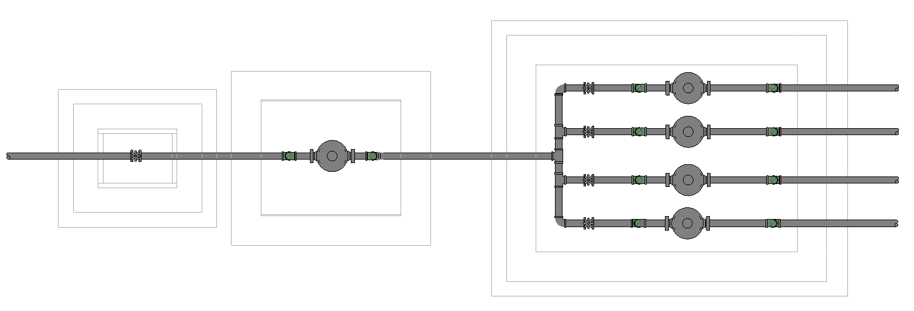
MAIN WATER METER

FLAT A
FROM
PUB MAIN
FLAT B

FLAT C
FLAT D

STOP VALVES

PLAN
FIGURE SCENARIO

Request For Information
- What is “as near as praticable” distance?
- The Rule description stated in 24_Appendix 2_COP rules.pdf for WTR 6.4.7 is different from what we have in IBS_PUB-CP 48-2005+Amd 1&2.pdf
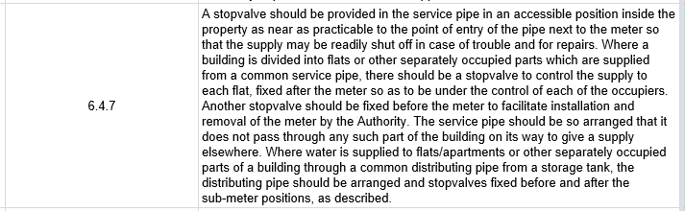

- We believe the Rule stated in 24_Appendix 2_COP rules.pdf actually directs to WTR 2.4.20 in IBS_PUB-CP 48-2005+Amd 1&2.pdf. Is this correct?
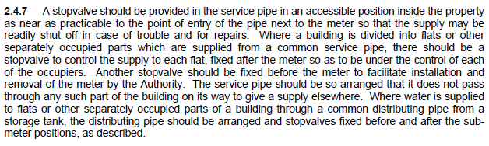

Model PreCheck

Required Elements | Required Attributes
FlowController | Name contains “Stop Valve”
FlowController | Name contains “Main Water Meter”
FlowController | Name contains “Sub Water Meter”

Rule Parameters

System Type
Cold Water |  | 
Hot Water
 | Sanitary
 | Sewerage
Vent

Element Type 1
State | Type | Property | Operator | Value
Include | IfcFlowController | Name | Contains | Stop Valve
Exclude |  | Any | Match | N.A.
 |  | Name | N.A. | <User defined>

Element Type 2
State | Type | Property | Operator | Value
Include | IfcFlowController | Name | Contains | Main Water Meter
Exclude |  | Any | Match | <User define>
 |  |  | N.A. | N.A.

Element Type 3
State | Type | Property | Operator | Value
Include | IfcFlowController | Name | Contains | Sub-meter
Exclude |  | Any | Match | <User define>
 |  |  | N.A. | N.A.

Element Type 1 Condition
*Shall be provided after Element Type 2

*Shall be provided before and after Element Type 3

Result Messages
- WTR 6.4.7 Provision of Stop Valves
  - Non-Compliant (TotalResultNumeric)
    - BuildingStorey (TotalResultPerFloorNumeric: ElementType1Name is not found.

  - Compliant (TotalResultNumeric)
    - BuildingStorey (TotalResultPerFloorNumeric): ElementType1NameNumeric is provided.

Sample Result Messages
- WTR 6.4.7 Provision of Stop Valves
- Non-compliant (4)
- Level 1 (1): Stop valve is not found.
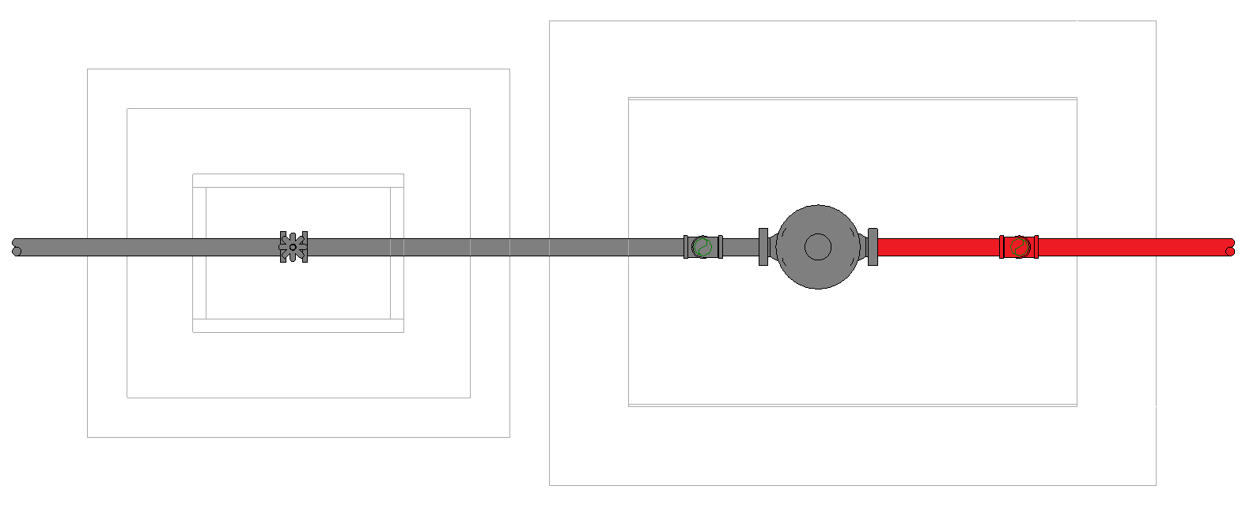

- Level 1 (1): Stop valve is not found.
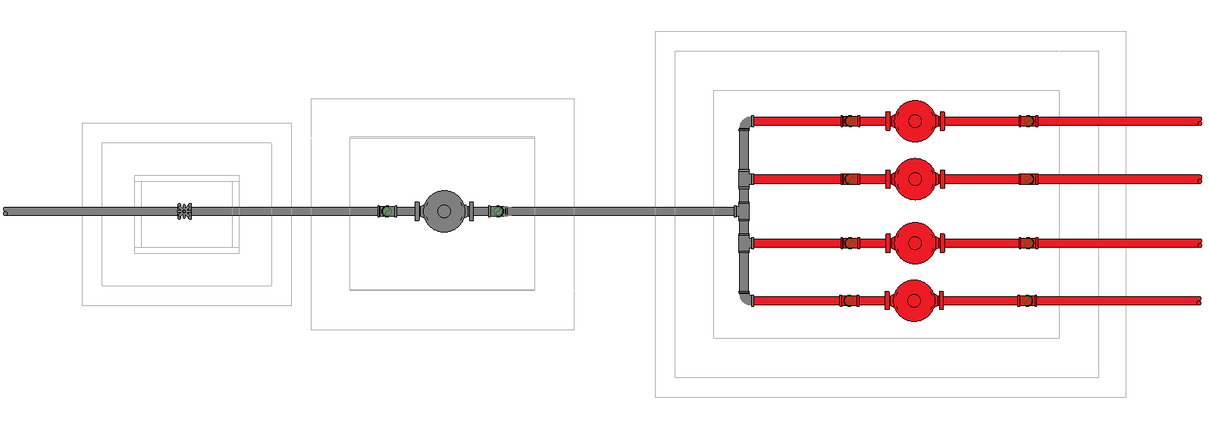

- Level 1 (1): Stop valve is not found.
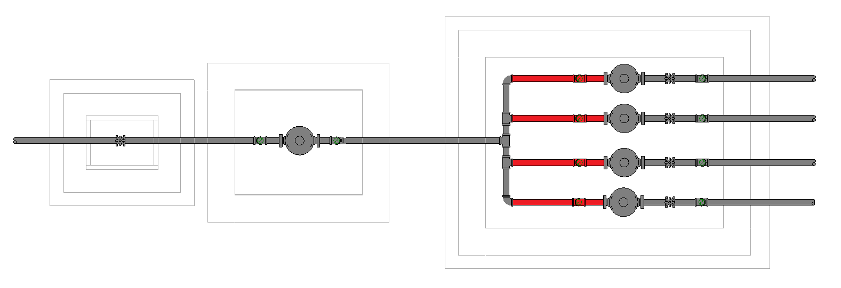

- Level 1 (1): Stop valve is not found.
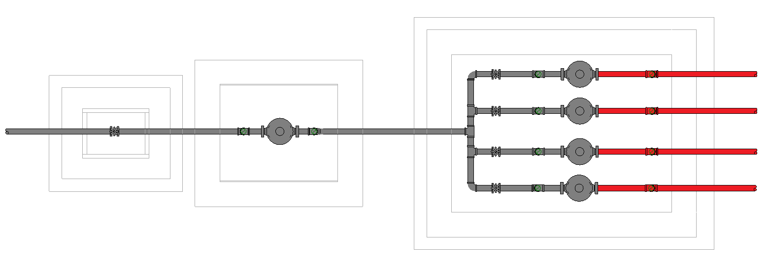

PLAN
PLAN
PLAN
PLAN

- Compliant (2)
  - Level 1 (1): Stop Valve 504.1 is provided.
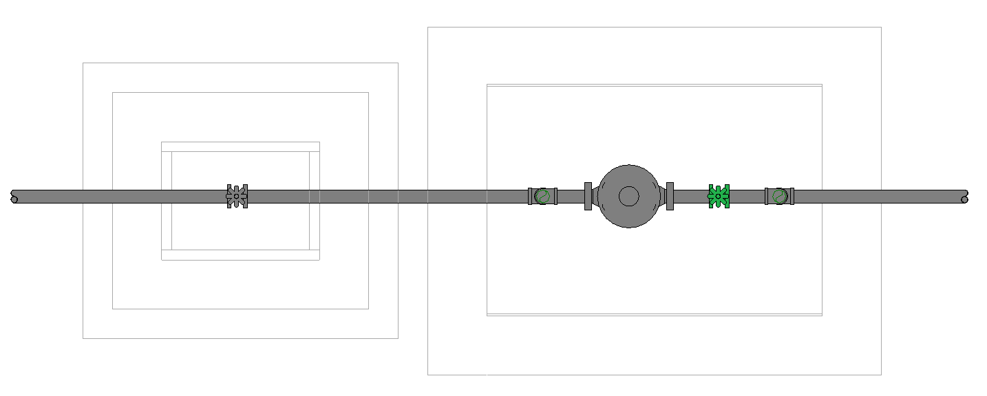

  - Level 1 (1): Stop Valve 504.2 is provided.

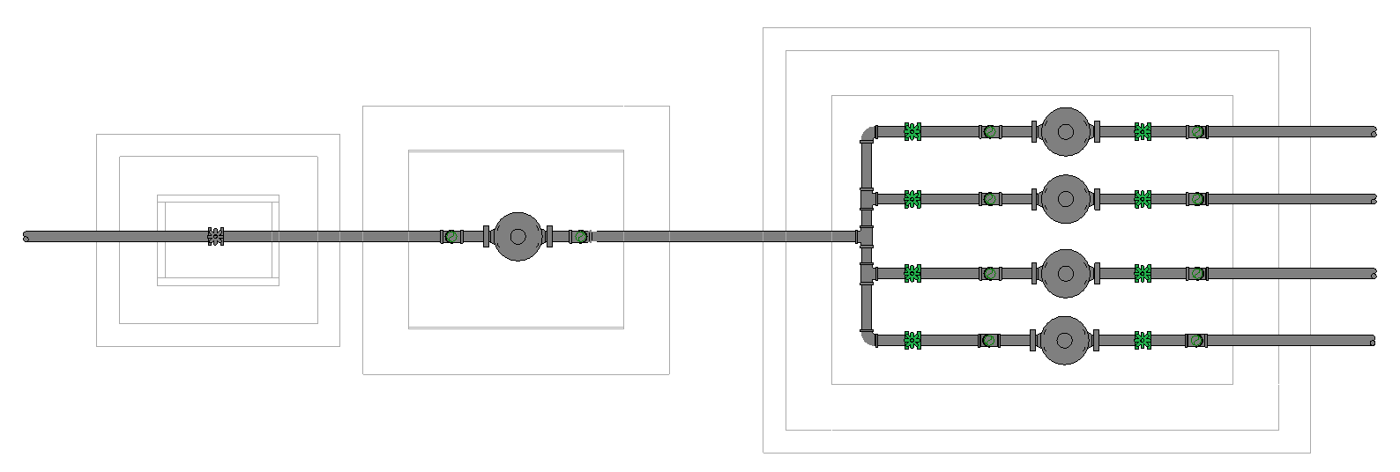
PLAN
PLAN

Sample Result Model Views
- WTR 6.4.7 Provision of Stop Valves
- Non-compliant
- Plan view.
- Highlight checked element.
- All other elements are translucent except checked element.
- Compliant
- Plan View.
- Highlight checked element.
- All other elements are translucent except checked element.

Testing Scenario Notes
- Scenario 01 - Compliant
- Level 1
- Stop valve is provided next to the water meter going to the building.

- Scenario 02 - Compliant
- Level 1
- Stop valves is provided before and after the water sub-meter of each flat of the building.

- Scenario 01 - Non-compliant
- Level 1
- Stop valve is not provided next to the water meter going to the building.

- Scenario 02 - Non-compliant 1
- Level 1
- Stop valves is not provided before and after the water sub-meter of each flat of the building

- Scenario 02 - Non-compliant 2
- Level 1
- Stop valves is provided only after the water sub-meter of each flat of the building.

- Scenario 02 - Non-compliant 3
- Level 1
- Stop valves is provided only before the water sub-meter of each flat of the building.

Model:
WTR 6.4.7 Scenario 01 Compliant.ifc
WTR 6.4.7 Scenario 02 Compliant.ifc
WTR 6.4.7 Scenario 01 Non-Compliant.ifc
WTR 6.4.7 Scenario 02 Non-Compliant 1.ifc
WTR 6.4.7 Scenario 02 Non-Compliant 2.ifc
WTR 6.4.7 Scenario 02 Non-Compliant 3.ifc

Modelling Guideline
- Specify Name containing “Valve” for relevant FlowController.
- Specify Name containing “Water Meter” for relevant FlowController.
- Specify Name containing “Sub-Water Meter” for relevant FlowController.

Specification Log
RA | Jessica Esquerra
Last edit date | 19 October 2018
ePC version
Updates | - V1

